**GUIDED NOTES – Lesson 2-8**

Transformations of Quadratics Name: ______________________ Period: ___

**Objective:** I can find the vertex form of a quadratic function and graph using transformations.

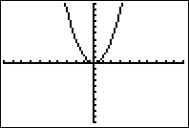

Transformations are all about how things _____________.

Let’s first look at the basic quadratic function of

We refer to this as the _____________________.

We are going to analyze transformations on this basic equation in vertex form:

|  |  |  |
| --- | --- | --- |
| **HORIZONTAL TRANSLATION (h)** | **VERTICAL TRANSLATION (k)** | **REFLECTION AND DILATION (a)** |
| Moves to left (h units) if h is added to x | Moves up (k units) if k is positive | Opens up if a is positive  Reflects down if a is negative |
| Moves to the right (h units) if h is subtracted from x | Moves down (k units) if k is negative | a > 1 stretched vertically  0 < a < 1 compressed vertically |

**EXAMPLE:** Graph and state the transformation from y = x2.



**y = (x – 5)2 + 3** Transformation:

Vertex:

Axis of symmetry:



**y = -2(x – 4)2** Transformation:

Vertex:

Axis of symmetry:



**y = ½(x + 6)2 – 3**  Transformation:

Vertex:

Axis of symmetry:

Recall that a quadratic function in standard form can be written: **f(x) = ax2 + bx + c**

The vertex form of a quadratic function is given as: **f(x) = a(x – h)2 + k**

We will now apply the concept of completing the square (from lesson 2-6) to convert a standard form function to its vertex form.

**EXAMPLES:** Write in vertex form. **y = a(x – h)2 + k**

y = x2 – 6x – 5 y = 2x2 + 8x + 7

Lastly, we need to be able to generate a quadratic equation in vertex form, from the vertex and one point (either given directly or from a graph).

Step 1 – Replace (h, k) with the vertex points.

Step 2 – Replace x and y with the other point given.

Step 3 – Solve for a.

Step 4 – Put a, h, and k, together in vertex form.

**EXAMPLE:** Write an equation in **EXAMPLE:** Write an equation in vertex

vertex form, given the graph form, given this graph below.

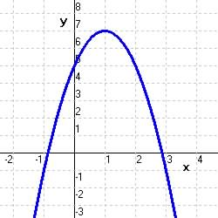has a vertex of (-4, 3) and goes

through the point (-3, 6).



